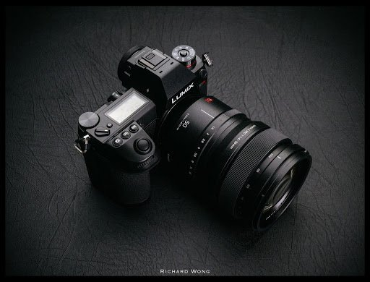

Panasonic Lumix S5 II Mirrorless Camera
The Panasonic Lumix S5 II is a professional full-frame mirrorless camera designed for photographers, filmmakers, and content creators who demand exceptional image quality and advanced video performance. Built with a rugged, weather-sealed magnesium alloy body, the S5 II combines portability with professional-grade durability, making it suitable for studio work, travel, wildlife, weddings, sports, and commercial productions.
The camera features a 24.2-megapixel Full-Frame CMOS sensor paired with the powerful Venus Engine image processor. This combination delivers outstanding image quality with rich colors, sharp details, excellent dynamic range, and superior low-light performance. The full-frame sensor also provides beautiful background blur (bokeh), making it ideal for portrait photography and cinematic video production.
One of the most significant improvements in the Lumix S5 II is its Phase Hybrid Autofocus System, which combines phase-detection and contrast-detection technologies for fast, accurate, and reliable subject tracking. The camera can intelligently detect and focus on people, animals, birds, cars, motorcycles, and other moving subjects, ensuring consistently sharp images and videos.
The Lumix S5 II is equipped with 5-axis In-Body Image Stabilization (IBIS) that offers up to 6.5 stops of stabilization. This allows photographers to capture clear handheld images in low-light conditions while enabling filmmakers to record smooth, stable footage without relying heavily on external stabilizers.
For videographers, the camera is a powerful production tool. It supports 6K video recording at 30fps, Cinema 4K and UHD 4K recording up to 60fps, and 10-bit 4:2:2 internal recording, delivering professional-quality footage suitable for documentaries, short films, YouTube content, commercials, and television production. It also supports V-Log/V-Gamut, providing a wide dynamic range for professional color grading.
The 3.68-million-dot OLED Electronic Viewfinder (EVF) offers a bright and highly detailed view for precise composition, while the 3-inch fully articulated touchscreen LCD provides flexible shooting angles for photography, videography, and vlogging.
The Lumix S5 II includes dual SD UHS-II card slots, built-in Wi-Fi and Bluetooth, USB-C connectivity, full-size HDMI output, microphone and headphone ports, making it a complete solution for professional multimedia production.

Key Features
- Camera Type: Full-Frame Mirrorless Camera
- Sensor: 24.2 MP Full-Frame CMOS Sensor
- Image Processor: Venus Engine
- Autofocus: Phase Hybrid Autofocus with AI Subject Detection
- Image Stabilization: 5-Axis In-Body Image Stabilization (Up to 6.5 Stops)
- Video Recording: 6K 30fps, Cinema 4K 60fps, UHD 4K 60fps
- Video Format: 10-bit 4:2:2 Internal Recording
- Viewfinder: 3.68M-dot OLED Electronic Viewfinder
- LCD Screen: 3-inch Fully Articulating Touchscreen
- Continuous Shooting: Up to 30 fps (Electronic Shutter)
- Storage: Dual UHS-II SD Card Slots
- Connectivity: Wi-Fi, Bluetooth, USB-C, HDMI
- Audio Ports: Microphone Input & Headphone Output
- Battery: High-Capacity Rechargeable Lithium-Ion Battery
- Body: Weather-Sealed Magnesium Alloy Construction
- Weight: Approximately 740 g (with battery and memory card)

Advantages
- Professional full-frame image quality
- Excellent low-light performance
- Fast and highly accurate Phase Hybrid Autofocus
- Powerful 5-axis image stabilization
- Professional 6K and Cinema 4K video recording
- Internal 10-bit video for advanced color grading
- Durable weather-resistant magnesium alloy body
- Fully articulating touchscreen for flexible shooting
- Dual SD card slots for backup and extended storage
- Ideal for both photography and professional filmmaking

Applications
The Panasonic Lumix S5 II is ideal for:
- Professional Photography
- Wedding Photography
- Portrait Photography
- Landscape Photography
- Wildlife Photography
- Sports Photography
- Travel Photography
- Commercial Photography
- Cinematic Filmmaking
- Documentary Production
- YouTube Content Creation
- Live Streaming
- Corporate Video Production
- Event Videography

